Schedule J – MDOC Service Level Agreements


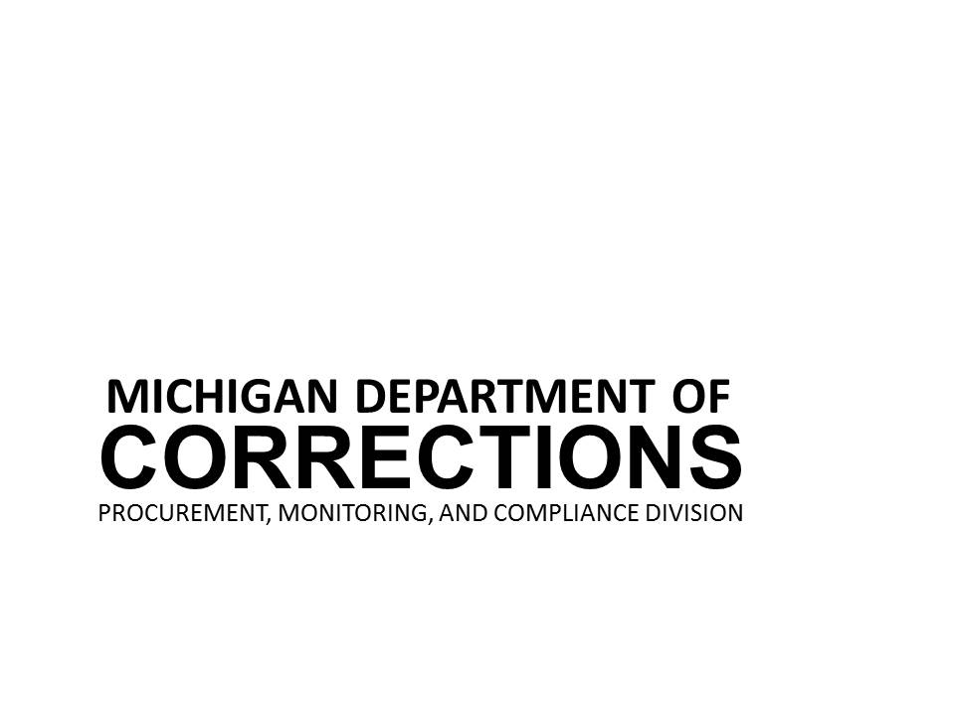

Agency/Vendor: MDOC/TBD
Contract #: TBD –
Effective Date: *Contract Start Date*

Metric 1: Contractor Training Completion
Definition and Purpose:
Contracted staff and/or subcontractor staff (as applicable) must complete MDOC-required training prior to entering MDOC facilities and/or working on any contract deliverables (per Contract section 1.3 Training).
MDOC-provided training must be completed each training year (defined as October 1st through September 30th). The annual deadline for training completion is September 30th.
Data Sources:
- MDOC MI-TRAIN web site training data.
- Other forms of training documentation (electronic or hard copies).
- Contractor organizational chart or quarterly contractor roster.
- MDOC Contractor Roster.
- Correspondence with MDOC Staff or the Contractor.
Methodology:
MDOC will conduct an annual audit of Data Sources 1-5.
Acceptable Standard:
The Acceptable Standard is 100% compliance.
Amount for Failing to Meet Service Level Agreement:
A credit of $250.00 will be assessed per finding for each contractor staff and/or subcontractor staff who do not complete MDOC-required training by the deadline.
If over 30% of contractor staff and/or subcontractor staff do not complete MDOC-required training by the deadline, an additional $1000.00 will be assessed.
Extenuating circumstances will be reviewed by the MDOC Contract Manager before any Service Credits are assessed. At the discretion of the State, these credits may be applied toward any payable due to the Contractor or be payable directly to the State of Michigan. Payments made directly to the State of Michigan shall be completed within 10 calendar days upon demand.

Metric 2: Reporting
Definition and Purpose:
The Contractor must ensure that accurate Monthly and Quarterly Reports (per Contract section 3.3 Reporting) are delivered via email to the MDOC within 15 calendar days from the close of the previous month/Quarter.
Data Sources:
- Monthly and Quarterly Reports provided by the Contractor.
- Correspondence with MDOC Staff.
Methodology:
Reconcile and review Data Sources 1 and 2 as needed.
Acceptable Standard:
The Acceptable Standard is 100% compliance.
Amount for Failing to Meet Service Level Agreement:
Reports must be received within 15 calendar days of the close of the previous month/Quarter. $100.00 will be assessed on the 16th day and every 5 business days thereafter until the reports are received by the MDOC.

Extenuating circumstances will be reviewed by the MDOC Contract Manager before any Service Credits are assessed. At the discretion of the State, these credits may be applied toward any payable due to the Contractor or be payable directly to the State of Michigan. Payments made directly to the State of Michigan shall be completed within 10 calendar days upon demand.

Metric 3: Proper Invoicing
Definition and Purpose:
Invoices must be provided to the State with accurate data (per contract section 6.1 Invoice Requirements).
Data Sources:
- 1. Monthly Invoices
- 2. Internal Agency data from SIGMA (The State of Michigan’s accounting application).
- 3. Correspondence with Agency Staff.
- 4. Correspondence from Contractor.
Methodology:
Reconcile and review Data Sources 1 – 4 as needed.
Acceptable Standard:
The Acceptable Standard is 100% compliance.
Amount for Failing to Meet Service Level Agreement:
Failure to ensure all invoices are provided correctly will result in a $250.00 invoice credit after the third incorrect invoice is submitted within any 12-month period for each account/DO.

Extenuating circumstances will be reviewed by the MDOC Contract Manager before any Service Credits are assessed. At the discretion of the State, these credits may be applied toward any payable due to the Contractor or be payable directly to the State of Michigan. Payments made directly to the State of Michigan shall be completed within 10 calendar days upon demand.

Metric 4: Compliances with Licensing Requirement
Definition and Purpose:
All Licensed Temporary Healthcare and Mental Health Professionals must maintain a current license for the position in which they are placed (per contract section 1.1 General Requirements). The Agency must ensure the MDOC is provided with a current copy of all licenses and an annual update when the license is renewed. Any individual who does not maintain the required licensure may be released from their assignment.
Data Sources:
- 1. Copy of licenses for Temporary Healthcare and Mental Health Professionals.
- 2. Data from Michigan Department of Licensing and Regulatory Affairs.
- 3. Correspondence with Agency Staff.
- 4. Correspondence from Contractor.
Methodology:
Reconcile and review Data Sources 1 – 4 as needed.
Acceptable Standard:
The Acceptable Standard is 100% compliance.
Amount for Failing to Meet Service Level Agreement:
Failure to ensure the license for any Temporary Healthcare and Mental Health Professionals is current will result in a $1,000.00 invoice credit per violation. If a current license is not provided within 72 hours, an additional $1,000.00 invoice credit will be assessed.

Current copies of licenses and renewal documentation must be received 30 calendar days prior to expiration. Failure to submit licensing documentation will result in a $250.00 invoice credit per violation.

Extenuating circumstances will be reviewed by the MDOC Contract Manager before any Service Credits are assessed. At the discretion of the State, these credits may be applied toward any payable due to the Contractor or be payable directly to the State of Michigan. Payments made directly to the State of Michigan shall be completed within 10 calendar days upon demand.
Metric 5: Prospective Candidates Meeting Minimum Qualifications
Definition and Purpose:
All Prospective Candidates for vacant Temporary Healthcare and Mental Health positions must meet the minimum qualifications for the position that they are applying for with the MDOC (per Contract section 1.2 Procedure).
Data Sources:
1. Copy of position descriptions for Temporary Healthcare and Mental Health Professionals.
2. Data from prospective candidates (including data submitted by agency during the application process). As a point of reference, some examples of this data source include (but are not limited to):
- Candidate's LEIN Form is submitted with incomplete and/or inaccurate information.
- Candidate submitted for the incorrect facility or shift.
- Prior MDOC employment is not included on the Candidate's resume.
- Candidate submitted who was previously declined by the MDOC.
- Candidate submitted with expired licenses or certifications.
3. Correspondence with Agency Staff.
4. Correspondence from Contractor.
Methodology:
Reconcile and review Data Sources 1 – 4 as needed.
Acceptable Standard:
The Acceptable Standard is 100% compliance.
Amount for Failing to Meet Service Level Agreement:
Failure to ensure the Prospective candidate for any Temporary Healthcare and Mental Health vacancy meets the current minimum qualifications will result in a $250.00 invoice credit per violation.

Extenuating circumstances will be reviewed by the MDOC Contract Manager before any Service Credits are assessed. At the discretion of the State, these credits may be applied toward any payable due to the Contractor or be payable directly to the State of Michigan. Payments made directly to the State of Michigan shall be completed within 10 calendar days upon demand.

